**V. Specifications**

A. Creating and logging to an account

When the user open the app, the first thing he will see will be a choice to either login to an account or sign up. If he choose to sign up, he will have to enter his username and password. The information will be sent to our database to check if this username is link to this password. If not, then it will ask again and if he want to recover his password. If he don’t remember the password, then he will have to input his email address. The information will be send to our database, who will send a link to his mail to recover his password.

If the user press the button sign up. Then, he will have to input a username, a password and a mail address. Then two buttons will appear, asking if he is a buyer or a seller of food. If he select buyer, he will have to input his location and select a category of food he prefer. If he chose seller, he will input also a his location, and he will select the categories of food he is selling. All this information will be filled in a class then sent to the database.

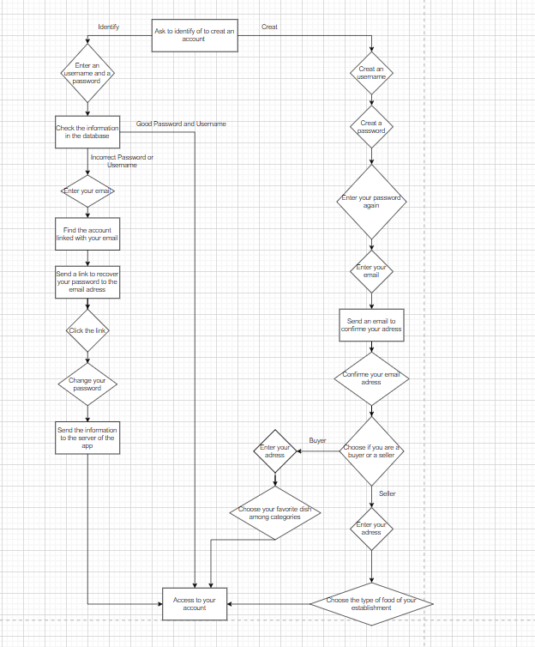

B. Selecting the type of purchase

After logging to his account, the app will show to the buyer two buttons. The first one ask if he wants to buy leftovers from restaurants. The second one, suggest to buy basic food like eggs, milk and yogurt with a close expiration date from a supermarket.

C. Customer Choice

Once the buyer has selected the first button, the one to receive leftovers from restaurants, a page with multiples categories of food, a price range and the max-min distance of the restaurant. At the bottom of the page, there will be two button, one that says “Save”, where the buyer save his selection. The information will be send to a the database. Firstly, to look for restaurants that fits in the buyer preference, but also to save his preference. Once the restaurants have been found, the database will send all there information, and they will appear in a list in the app.

The other will say “No Selection”. This means that the app will find randomly a restaurant. For that, the preference like the categories and the price will be chosen randomly by the app, only the address has to be the same city. The random information will be sent to the database, to find multiples restaurants fitting the categories. Then they will appear as a list to the buyer.

If the buyer has selected the other button, the one to receive food from supermarket. Then the process is almost the same as the first button. The buyer can set up a price range, choose a category and a min-max distance from him. The information is also sent to the database to find a list of groceries stores that fits the preference, and save the preference of this buyer. Then, the groceries stores that fits this category are shown as a list in the app.   
  
D. Payment and pickup

Once the buyer has chosen his restaurant or groceries store, the different food available will appear, with their price, as a list. The buyer will just have to click on the name of one food from the list. After, a calendar will appear, where the buyer can set the hour and the day of the delivery within the limits of the restaurant or groceries store. Then a button will appear asking if the buyer want to bring his own container for the food. If he don’t, he can just press on a cross on the top-right of the screen. Finally, two buttons will appear, one asking to pay online, the other to pay directly at the counter.

If the buyer choose to pay at the counter, then the app will send the class that took all the information of his order to the server. Then, the server will send it to the account of the seller. A mail will also be sent to the email address of the seller account.

If he choose otherwise, then he will have to fill his financial information for a payment online. The buyer can choose to either pay by Paypal or by credit card, by pressing some buttons. He will have to fill his financial information. Then the information will be sent to our Payment Gateway. Once the payment is complete, the order is sent to the restaurant or grocery store like in the payment at the counter option. The application will wire transfer the money to the seller.